**IEEE Global-**

The Institute of Electrical and Electronics Engineers is a professional association with its corporate office in New York City and its operations centre in Piscataway, New Jersey. It was formed in 1963 from the amalgamation of the American Institute of Electrical Engineers and the Institute of Radio Engineers. Today, it is the world's largest association of technical professionals with more than 420,000 members in over 160 countries around the world. Its objectives are the educational and technical advancement of electrical and electronic engineering, telecommunications, computer engineering and allied disciplines.



IEEE LOGO

**Name-**

IEEE stands for the "Institute of Electrical and Electronics Engineers". The association is chartered under this full legal name. IEEE's membership has long been composed of engineers and scientists. Allied professionals who are members include computer scientists, software developers, information technology professionals, physicists, and medical doctors, in addition to IEEE's electrical and electronics engineering core. For this reason the organization no longer goes by the full nAme, except on legal business documents, and is referred to simply as IEEE.

The IEEE is dedicated to advancing technological innovation and excellence. It has about 420,000 members in about 160 countries, slightly less than half of whom reside in the United States.

**History-**

The major interests of the AIEE were wire communications (telegraphy and telephony) and light and power systems. The IRE concerned mostly radio engineering, and was formed from two smaller organizations, the Society of Wireless and Telegraph Engineers and the Wireless Institute. With the rise of electronics in the 1930s, electronics engineers usually became members of the IRE, but the applications of electron tube technology became so extensive that the technical boundaries differentiating the IRE and the AIEE became difficult to distinguish. After World War II, the two organizations became increasingly competitive, and in 1961, the leadership of both the IRE and the AIEE resolved to consolidate the two organizations. The two organizations formally merged as the IEEE on January 1, 1963.

Notable presidents of IEEE and its founding organizations include Elihu Thomson (AIEE, 1889–1890), Alexander Graham Bell (AIEE, 1891–1892), Charles Proteus Steinmetz(AIEE, 1901–1902), Robert H. Marriott (IRE, 1912), Lee De Forest (IRE, 1930), Frederick E. Terman (IRE, 1941), William R. Hewlett (IRE, 1954), Ernst Weber (IRE, 1959; IEEE, 1963), and Iva Getting (IEEE, 1978).

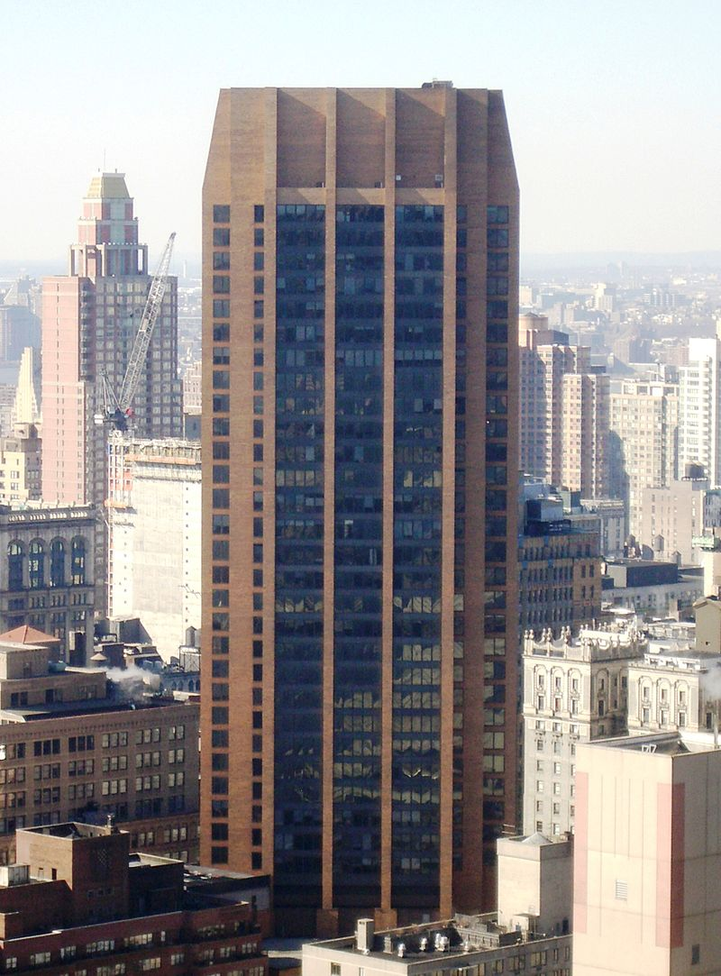

The IEEE Corporate Office is on the 17th floor of 3Park Avenue in New York City

**Organization-**

The IEEE is incorporated under the Not-for-Profit Corporation Law of the state of New York.[5] It was formed in 1963 by the merger of the Institute of Radio Engineers (IRE, founded 1912) and the American Institute of Electrical Engineers (AIEE, founded 1884). The IEEE serves as a major publisher of scientific journals and organizer of conferences, workshops, and symposia (many of which have associated published proceedings). It is also a leading standards development organization for the development of industrial standards (having developed over 900 active industry technical standards) in a broad range of disciplines, including electric power and energy, biomedical technology and healthcare, information technology, information assurance, telecommunications, consumer electronics, transportation, aerospace, and nanotechnology. IEEE develops and participates in educational activities such as accreditation of electrical engineering programs in institutes of higher learning. The IEEE logo is a diamond-shaped design which illustrates the right hand grip rule embedded in Benjamin Franklin's kite, and it was created at the time of the 1963 merger. IEEE has a dual complementary regional and technical structure – with organizational units based on geography (e.g., the IEEE Philadelphia Section, the IEEE Buenaventura Section, IEEE South Africa Section) and technical focus (e.g., the IEEE Computer Society). It manages a separate organizational unit (IEEE-USA) which recommends policies and implements programs specifically intended to benefit the members, the profession and the public in the United States. The IEEE includes 39 technical Societies, organized around specialized technical fields, with more than 300 local organizations that hold regular meetings. The IEEE Standards Association is in charge of the standardization activities of the IEEE. The IEEE History Centre became a feeder organization to the Engineering and Technology History Wiki (ETHW) in 2015. The new ETHW is a cooperative effort by various engineering societies as a formal repository of topic articles, oral histories, first-hand histories, Landmarks + Milestones and archival documents. The IEEE History Centre is annexed to Stevens University Hoboken, NJ. In 2016, the IEEE acquired GlobalSpec, adding the provision of engineering data for a profit to its organizational portfolio.

**IEEE Mission & Vision-**

IEEE is the world’s largest technical professional organization dedicated to advancing technology for the benefit of humanity. Below, you can find IEEE's mission and vision statements.

**Mission statement-**

IEEE's core purpose is to foster technological innovation and excellence for the benefit of humanity.

**Vision statement-**

IEEE will be essential to the global technical community and to technical professionals everywhere, and be universally recognized for the contributions of technology and of technical professionals in improving global conditions.

## Core values-

* Trust: being a trusted and unbiased source of technical information, and forums, for technical dialog and collaboration.
* Growth and nurturing: encouraging education as a fundamental activity of engineers, scientists, and technologists at all levels and at all times; ensuring a pipeline of students to preserve the profession.
* Global community building: cultivating active, vibrant, and honest exchange among cross-disciplinary and interdisciplinary global communities of technical professionals.
* Partnership: promoting a culture of respect for the employee and volunteer, valuing contributions at all levels of the organization, investing in training and development to enhance capabilities, empowering individuals to make a positive difference, and building a membership organization based on a strong volunteer-staff partnership to serve the profession.
* Service to humanity: leveraging science, technology, and engineering to benefit human welfare; promoting public awareness and understanding of the engineering profession.
* Integrity in action: fostering a professional climate in which engineers and scientists continue to be respected for their exemplary ethical behaviour and volunteerism.

**2015-20 Goals-**

* Expand and enable dynamic, nimble, flexible, and diverse communities to help individuals from around the world to share, collaborate, network, debate, and engage with one another.
* Provide technically vital forums for the discussion, development, and dissemination of authoritative knowledge related to traditional technologies, while focusing more of our resources towards serving the professionals working on emerging and disruptive technologies.
* Lead humanitarian efforts around the world to use technology to solve the world’s most challenging problems.
* Leverage IEEE’s technology-related insight to provide governments, NGOs and other organizations, and the public with innovative and practical recommendations to address public policy issues.

**Key Intiatives supporting the Goals-**

* Provide more opportunities, products, and services aimed at increasing our value to professionals working in the industry; particularly younger professionals and entrepreneurs.
* Ensure the vitality and relevance of our core activities in standards, conferences, education, and publications while providing increased value to our members.
* Develop programs in public service focused on knowledge and technology in our fields of interest, related to public policy and humanitarian efforts.
* Evaluate and adapt organizational structures and processes to meet the demands of a changing environment while managing the financial and sustainable health of IEEE.

**IEEE Region 10(Asia Pacific Region)-**

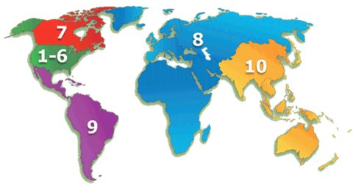

**1955-67**

IEEE (IRE) sections began to develop in the Asia-Pacific region prior to the formation of a Region 10 district. New Zealand started in 1968, Pakistan in 1968, India (Bombay) in 1969 and Tokyo in 1955 (as part of the IRE). The formation of Region 10 was approved by the IEEE Board of Directors at the 24 August 1966 meeting. The new Bylaw first appeared in the 3 November 1966 edition of the Bylaws noting that it would be effective 1 January 1967. The result was that, quoting from Martin Bastiaans’ [A short history of IRE Region 9 / IEEE Region 8](http://ethw.org/w/images/a/a6/R8_history.pdf) “on 1 January 1967 South America became Region 9, with Region 10 covering other parts of the world, still including a great part of Africa; finally on 1 January 1981 the remainder of Africa became part of Region 8.”

**1967-72**

The inaugural steering director for Region 10 was Dr.Shigeo Shima of Japan who was offered this task for 1967-68 by the IEEE Assembly.  Then began establishment of IEEE Sections and the gradual development of a community of interest in the Asia-Pacific region.  The original definition of Region 10 was ‘all remaining areas not included in the Regions 1 through 9′.

In 1971 Mr. Tatsuji Nomura of NHK Japan, the then director, took the initiative of forming a regional committee. The existing IEEE Sections in the region namely India, New Zealand, Pakistan and Tokyo were represented on that committee and the first meeting took place at the Peninsular Hotel, Hong Kong in early July 1971. That first meeting was exploratory. Section chairmen exchanged ideas and experiences and sought solutions to problems of Section administration and Section operation.

Since then the regional committee has met annually, somewhere in the region, on occasions with IEEE Headquarters officers present to assist and advise. Over these years committee evolved up to the present as the deliberating region.

**1973-76**

The Region 10 Student Paper Contest, introduced in 1974, was the first major exercise undertaken on a region-wide basis The drafting and approval of the rules of the contest was the outcome of considerable study and discussion by the regional committee.  This was a natural development of the student activities function of the committee. Also innovated in the years leading up to 1974 were important section technical conferences in India, Japan and New Zealand.

By 1976 section formation in the countries of the region was virtually complete. Moreover, in India where just one country section had been formed initially, new independent sections were being established in the important cities.

An important parallel development was the formation of multiple technical chapters of technical groups in Tokyo Section, where formation of new chapters has continued up to the present. Several chapters were also formed elsewhere in the region, in India and New Zealand. The formation of multiple IEEE Sections in India was followed by establishment of the all India IEEE Council, the first in Region 10 with [Mr. Faqir Kohli](http://ethw.org/Faqir_Chand_Kohli), a past regional director, as founding chairman. The regional committee gave much study to educational activities and the arranging of lecture tours by distinguished IEEE speakers. Several such tours took place in the region.

**1977-80**

In the period 1977-78 region 10 office bearers were apprehensive about the growing size of the regional committee and the mounting cost of staging the annual meeting. The increase in committee membership resulted in part from formation of additional sections in countries where one section existed already. As a reaction to this situation a special formula was hammered out covering reimbursement of costs to attendees from the regional treasury.

The regional committee from inception in 1971 through until the end of 1980 was in search of its identity and mission in the region and functioned by and large as a discussion group of elected section representatives without set parliamentary procedures and without an elected region 10 delegate. Preoccupation with side issues tended to inhibit the development of important objectives in the region.

In 1979, on the initiative of the serving director Dr.S.Y. King, the regional committee accepted the long overdue and task of drafting and approving a set of Region 10 Bylaws covering the election of Region 10 officers, voting procedures within the committee and the essentials of committee operation and management.

In 1979 the territory of the region was amended to exclude Africa which with the mutual agreement of other concerned was added to the territory of Region 8, namely Europe.

**1981-84**

Under the newly introduced and approved Region 10 Bylaws, Region 10 directors were elected by the membership of Region 10, beginning with the election held in 1980 for the 1981 year. Prior to 1980, the Region 10 director had been elected by the IEEE Assembly. The first Region 10 Delegate and Director to be elected was Dr. V. Prasad Kodali of New Delhi, who was a petition candidate, took office in 1981.

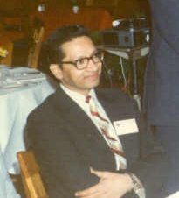

**Dr. V Pradas Kodali**

Dr V Prasad Kodali, visiting the New South Wales Section members, Sydney (1981)

In 1981-82 the regional committee, with a new sense of purpose, gave considerable attention to forward planning and to improving the organization and administration of Region 10 to give effect to these plans. New programmes were instituted.

The Region 10 bylaws were amended in respect of election of vice chairman by the region. Procedural guidelines were introduced.

A significant first in 1981-82 for the region was the inception of TENCON, an international technical conference initiated and hosted by Hong Kong Section and co-sponsored by Region 10.

In 1981 the IEEE membership in Region 10 passed the 10,000 mark, a growth rate of better than 10 per cent having been sustained for many years. The prediction for 1984, the Centennial year was 15,000 members.

It is interesting to note that in 1971 the number of regional committee members was just 5 whereas a decade later in 1981-82 this number was 27. Also there were 8 special guests at the regional committee meeting held in 1982 in New Delhi, so the attendance possible had risen to 35. Special guests at that meeting included the IEEE President, General Manager, Vice President for Regional Activities, Vice President for Technical Activities, and Presidents of the Computer, AES, CHMT and MTT Technical Societies.

Plans were laid in 1981-82 for marking the Centennial ln 1984. These plans included preparations for “Blue Book History” publication of the Region 10 and for the Region to participate in commemorative activities. These plans were carried forward in 1983 and included preparations for the Region 10 Centennial Banquet which was held in Singapore during TENCON II.

Dr Harry Green was first “elected” Region 10 Director for 1983-84. This coincided with minor Region 10 boundary adjustments. Prior to 1983, all Region 10 directors were simply appointed for a fixed 2 year term by headquarters, while Regions 1 through 9 had all elected their representatives. This procedural update brought Region 10 under the same governance nd electrion rules that had applied to the rest of the IEEE, and in some ways allowed Region 10 to progress as a formally recognised region.

**Recent activity**

IEEE Region 10 membership exceeded 100,000 for the first time in 2012.

|  |  |  |  |
| --- | --- | --- | --- |
| **Membership type** | **No. of members** | **% Increase 2009-2011** | **Among IEEE OU as of 2011** |
| Higher grade | 50,755 | 9.25% | 2nd highest |
| Graduate students | 11,788 | 8.9% | Highest |
| Undergraduate students | 90,593 | 11.82% | Highest |

**Region 10 Entities**

|  |  |  |
| --- | --- | --- |
| **Entity – Office** |  |  |
| Asia Pacific Operations Centre | Singapore |  |

|  |  |  |
| --- | --- | --- |
| **Entity – Council** | **Geocode** | **Formed** |
| Australia Council | R0 05 | 30 May 1986 |
| [China Council](http://ethw.org/IEEE_China_Council_History) | R0 00 | 14 Jun 2007 |
| [India Council](http://ethw.org/IEEE_India_Council_History) | R0 01 | 20 May 1976 |
| [Japan Council](http://ethw.org/IEEE_Japan_Council_History) | R0 09 | 25 Jun 1999 |
| [New Zealand Council](http://ethw.org/IEEE_New_Zealand_South_Section_History) | R0 03 | 22 Aug 1980 |
| [Korea Council (v1)](http://ethw.org/IEEE_Korea_Council_History) |  | 1997-2000 |
| [Korea Council (v2)](http://ethw.org/IEEE_Korea_Council_History) |  | 2009 |

The Korea Council was orginally disbanded in 2000 due to issues with bylaws, cooperation and misunderstandings. the R10 committee agreed to re-form the Council in 2009, with agreement from all Korean Sections.

|  |  |  |
| --- | --- | --- |
| **Entity – Section** | **Geocode** | **Formed** |
| [Australia Capital Territory](http://ethw.org/IEEE_Australian_Capital_Territory_Section_History) | R0 0561 | 18 Nov 1988 |
| [Bangalore](http://ethw.org/IEEE_Bangalore_Section_History) | R0 0119 | 13 Jul 1976 |
| [Bangladesh](http://ethw.org/IEEE_Bangladesh_Section_History) | R0 0073 | 20 Nov 1993 |
| [Beijing](http://ethw.org/IEEE_Beijing_Section_History) | R0 0251 | 1 Dec 1984 |
| [Bombay (Mumbai)](http://ethw.org/IEEE_Bombay_%28Mumbai%29_Section_History) |  | 13 Jul 1976 |
| [Changwon](http://ethw.org/IEEE_Changwon_Section_History) |  | 3 Feb 1991 |
| [Chengdu](http://ethw.org/IEEE_Chengdu_Section_History) |  | 18 Nov 2006 |
| [Daejeon](http://ethw.org/IEEE_Daejeon_Section_History) | R0 0067 | 17 Jun 1991 |
| [Delhi](http://ethw.org/IEEE_Delhi_Section_History) |  | 13 May 1976 |
| [Fukuoka](http://ethw.org/IEEE_Fukuoka_Section_History) |  | 14 Nov 1998 |
| [Gujarat](http://ethw.org/IEEE_Gujarat_Section_History) |  | 15 Aug 1990 |
| [Harbin](http://ethw.org/IEEE_Harbin_Section_History) |  | 18 Nov 2006 |
| [Hiroshima](http://ethw.org/IEEE_Hiroshima_Section_History) |  | 14 Nov 1998 |
| [Hong Kong](http://ethw.org/IEEE_Hong_Kong_Section_History) | R0 0007 | 14 Dec 1971 |
| [Hyderabad](http://ethw.org/IEEE_Hyderabad_Section_History) |  | 14 May 1984 |
| [Indonesia](http://ethw.org/IEEE_Indonesia_Section_History) |  | 16 Feb 1988 |
| [Islamabad](http://ethw.org/IEEE_Islamabad_Section_History) |  | 12 Feb 2000 |
| [Kansai](http://ethw.org/IEEE_Kansai_Section_History) |  | 14 Nov 1998 |
| [Karachi](http://ethw.org/IEEE_Karachi_Section_History) | R0 0041 | 17 Jul 1982 |
| [Kerala](http://ethw.org/IEEE_Kerala_Section_History) |  | 18 Nov 1983 |
| [Kharagpur](http://ethw.org/IEEE_Kharagpur_Section_History) |  | 13 May 1985 |
| [Kolkata](http://ethw.org/IEEE_Kolkata_Section_History) |  | 28 Sep 1978 |
| [Kwangiu](http://ethw.org/IEEE_Kwangju_Section_History) |  | 24 Jun 2000 |
| [Lahore](http://ethw.org/IEEE_Lahore_Section_History) (was orginally Pakistan) |  | 19 Sep 1968 |
| [Macau](http://ethw.org/IEEE_Macau_Section_History) | R0 0097 | 14 Nov 2003 |
| [Madras (Chennai)](http://ethw.org/IEEE_Madras_%28Chennai%29_Section_History) |  | 28 Apr 1978 |
| [Malaysia](http://ethw.org/IEEE_Malaysia_Section_History) |  |  |
| [Nagoya](http://ethw.org/IEEE_Nagoya_Section_History) |  |  |
| [Nanjing](http://ethw.org/IEEE_Nanjing_Section_History) |  |  |
| [New South Wales](http://ethw.org/IEEE_New_South_Wales_Section_History) (was Australia Section) | R0 0509 | 16 Aug 1972 |
| [New Zealand Central](http://ethw.org/IEEE_New_Zealand_Central_Section_History) |  | 25 Aug 2007 |
| [New Zealand North](http://ethw.org/IEEE_New_Zealand_North_Section_History) |  | 4 Dec 1980 |
| [New Zealand South](http://ethw.org/IEEE_New_Zealand_South_Section_History) |  | 4 Dec 1980 |
| [Northern Australia](http://ethw.org/IEEE_North_Queensland_Section_History) (was North Qld) |  | 29 Jan 1994 |
| [Queensland](http://ethw.org/IEEE_Queensland_Section_History) |  | 22 Feb 1985 |
| [Republic of Philippines](http://ethw.org/IEEE_Republic_of_Philippines_Section_History) | R0 0015 | 4 Dec 1974 |
| [Sapporo](http://ethw.org/IEEE_Sapporo_Section_History) |  |  |
| [Sendai](http://ethw.org/IEEE_Sendai_Section_History) |  |  |
| [Seoul](http://ethw.org/IEEE_Seoul_Section_History) |  |  |
| [Shanghai](http://ethw.org/IEEE_Shanghai_Section_History) |  |  |
| [Shikoku](http://ethw.org/IEEE_Shikoku_Section_History) |  |  |
| [Shin-etsu](http://ethw.org/IEEE_Shin-etsu_Section_History) | R0 0904 | 26 Jun 2006 |
| [Singapore](http://ethw.org/IEEE_Singapore_Section_History) |  | 17 Jun 1977 |
| [South Australia](http://ethw.org/IEEE_South_Australia_Section_History) |  | 23 Aug 1985 |
| [Sri Lanka](http://ethw.org/IEEE_Sri_Lanka_Section_History) | R0 0002 | 14 Nov 2003 |
| [Taegu](http://ethw.org/IEEE_Taegu_Section_History) |  | 11 May 1992 |
| [Tainan](http://ethw.org/IEEE_Tainan_Section_History) |  | 20 Jun 2003 |
| [Taipei](http://ethw.org/IEEE_Taipei_Section_History) |  | 16 Oct 1974 |
| [Thailand](http://ethw.org/IEEE_Thailand_Section_History) |  | 9 Nov 1977 |
| [Tokyo](http://ethw.org/IEEE_Tokyo_Section_History) |  | 5 Dec 1955 |
| [Uttar Pradesh](http://ethw.org/IEEE_Uttar_Pradesh_Section_History) |  | 11 May 1992 |
| [Victorian](http://ethw.org/IEEE_Victorian_Section_History) | R0 0543 | 12 Aug 1983 |
| [Vietnam](http://ethw.org/IEEE_Vietnam_Section_History) | R0 0016 | 14 Feb 2007 |
| [Western Australia](http://ethw.org/IEEE_Western_Australia_Section_History) | R0 0547 | 24 May 1984 |
| [Wuhan](http://ethw.org/IEEE_Wuhan_Section_History) | R0 0218 | 14 Feb 2007 |
| [Xian](http://ethw.org/IEEE_Xian_Section_History) | R0 0212 | 18 Nov 2006 |

Membership Profile

[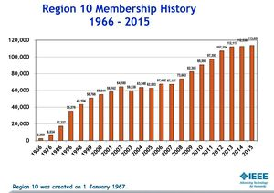](http://ethw.org/File:R10_Membership_History.PNG)

Reghion 10 Membership History

Region Executive

|  |  |  |
| --- | --- | --- |
| Year | Director | Host Section / Country |
| 1967-1968 | Shigeo Shima | Tokyo / Japan |
| 1969-1970 | D G Lampard | Sydney/Australia |
| 1971-1972 | Tatsuji Nomura | Tokyo / Japan |
| 1973-1974 | F C Kohli | Bombay / India |
| 1975-1976 | Hiroshi Shinkawa | Section ? / Japan |
| 1977-1978 | James J Vasseleu | New South Wales / Australia |
| 1979-1980 | S Y King | ?? / ?? |
| 1981-1982 | V Prasad Kodali | Hyderabad / India |
| 1983-1984 | Harry E Green | South Australia / Australia |
| 1985-1986 | Irving Ho | ?? / ?? |
| 1987-1988 | Ah Choy Liew | Singapore / Singapore |
| 1989-1990 | Morarji V. Chauhan | Section? / India |
| 1991-1992 | Souguil J M Ann | Seoul / Korea |
| 1993-1994 | Tsuneo Nakahara | Tokyo / Japan |
| 1995-1996 | Paul Y S Cheung | Hong Kong / Hong Kong |
| 1997-1998 | Harbans L Bajaj | Delhi / India |
| 1999-2000 | Takuo Sugano | Tokyo / Japan |
| 2001-2002 | Teck-Seng Low | Singapore / Singapore |
| 2003-2004 | [Jung U Seo](http://ethw.org/Oral-History:Jung_Uk_Seo) | Seoul / Korea |
| 2005-2006 | Seiichi Takeuchi | Tokyo / Japan |
| 2007-2008 | Janina Mazierska | Northern Australia / Australia |
| 2009-2010 | Yong Jin Park | Seoul (Korea) |
| 2011-2012 | Lawrence Wong | Singapore / Singapore |
| 2013-2014 | Toshio Fukuda | Section? / Japan |
| 2015-2016 | Ramakrishna Kappagantu | Section? / India |

**About IEEE Student Chapter, DIT University:**

The IEEE Student Chapter of DIT University brings under its umbrella some of the smartest, coolest and geekiest tech freaks on the campus. The chapter has its doors open to just about anybody who has the willingness to LEARN. The vision is not to mentor these individuals into technically sound individuals alone, but also to groom them into dynamic team players, who will in turn mentor their peers and juniors and keep the cycle going. Members exchange ideas and thoughts, interact, seek and extend support, and collaborate on projects. In this way, the chapter is very much a closely knit family.  Keeping in line with the motto of IEEE: ‘Advancing Technology for Humanity', the chapter works to develop a sense of appreciation among students towards electronics, computer science and related fields. Going beyond the standard textbook approach, it conducts several workshops and events to let students get hands-on experience with technically relevant hardware and software, which may also be important from the industrial point of view. It works in close coordination with the Google Student Community of the university.

**Activities**

* PCB and Embedded Workshop
* Cyber Security
* Web Development
* Raspberry Pi + Machine Learning
* Design Thinking
* In-house training program (machine learning, embedded, image processing, etc)
* Big O (Workshop+ Competition)
* PCB Workshop
* Image Processing using open CV

**Projects undergoing:**

* Quadcopter We’re trying to build a real time data acquisition drone which can be remotely maneuvered.
* INDIA’S DIGITAL FOOTPRINT Quadcopter It’s Google Student Community’s campaign about making India Digitally Alive one city at a time. In support with Indian Government’s Digital India Campaign, it promotes Digital Marketing and Online Business Management.
* DIGI CLUBS “Information should be available freely to everyone” With the Digi-Clubs project we aim to give all the clubs in a college a single platform where they can share about their inspiring projects and other works. Anything can be shared from Events and Meetings to Project Stories. We believe , every unnoticed event is a missed opportunity!
* Micromouse We’re trying to build intelligent a bot solving the complex maze in less time very efficiently.
* led cube The intensity of led’s varies with equalizer settings of music connected to it.